AzureDevOps-Zero-to-Hero/Day1 at main · piyushsachdeva/AzureDevOps-Zero-to-Hero · GitHub
https://github.com/piyushsachdeva/AzureDevOps-Zero-to-Hero/tree/main/Day1
Day 1:
What is Cloud Computing?
To run an application, you must purchase computing, storage, and hardware. Cloud computing minimizes these upfront expenses, and you can rent or lease hardware from cloud providers such as AWS/Azure/GCP.

Cloud Computing aims at
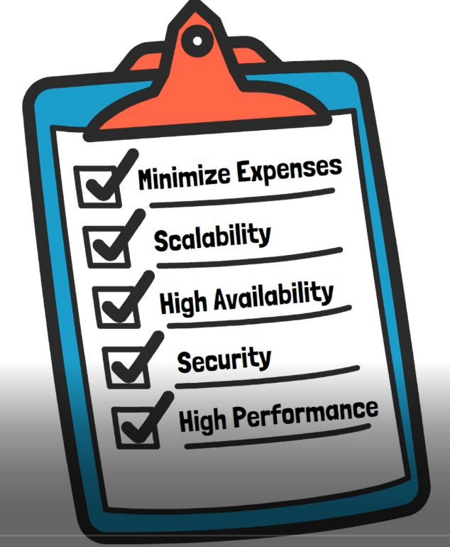

IaaS VS PaaS VS SaaS
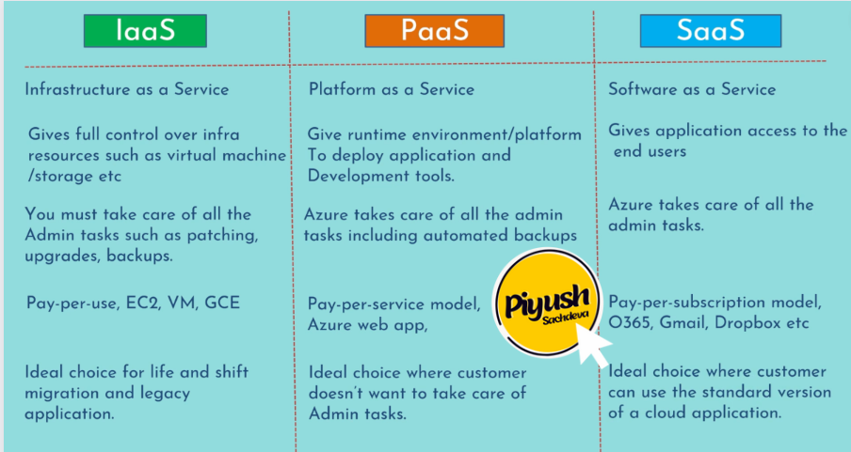
Shared Responsibility Model in Azure
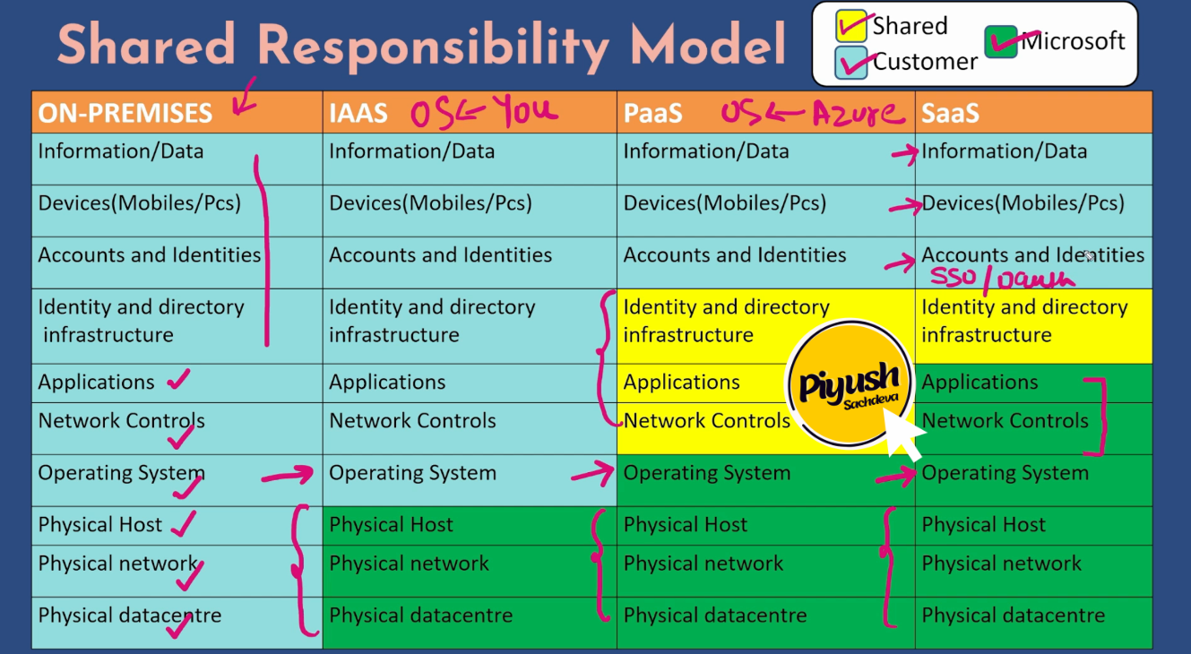

Traditional Build and Deployment workflow
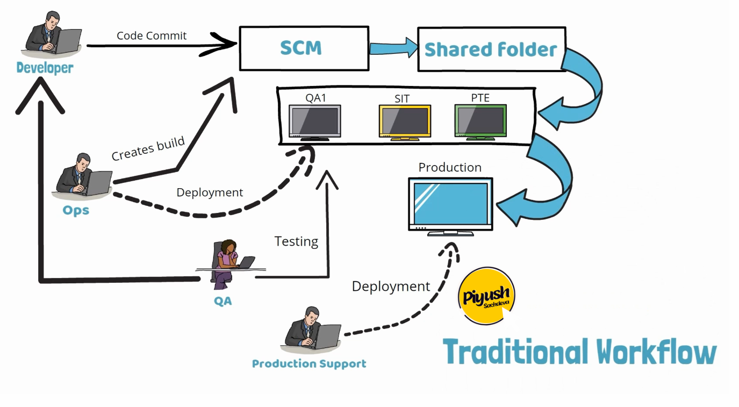
What is the Waterfall model?
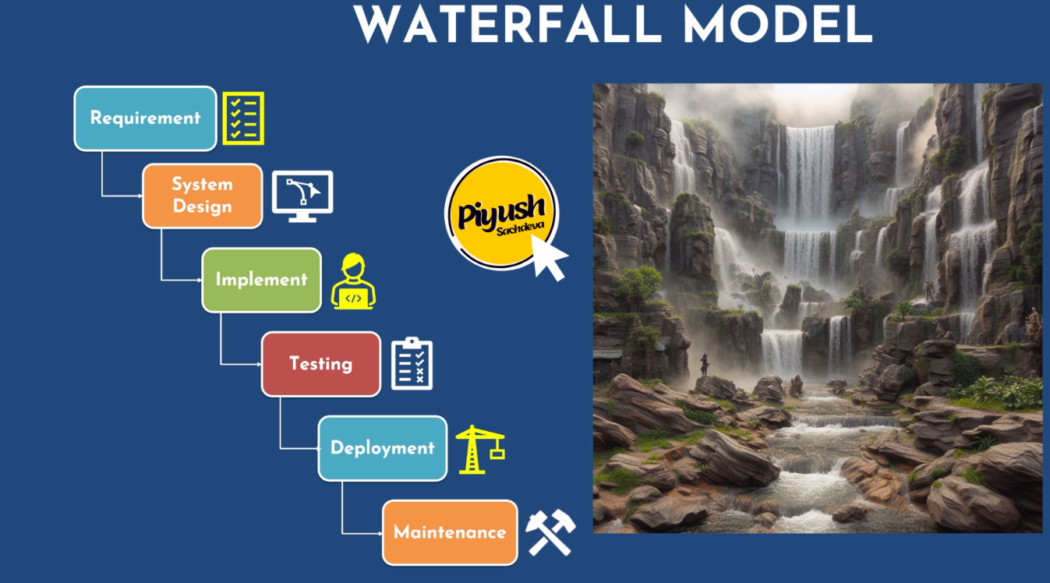

What were the challenges with the waterfall model?
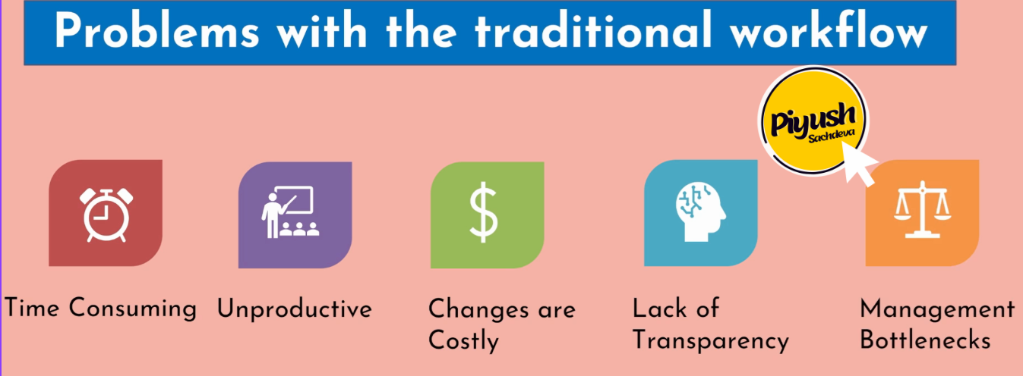

What is Agile
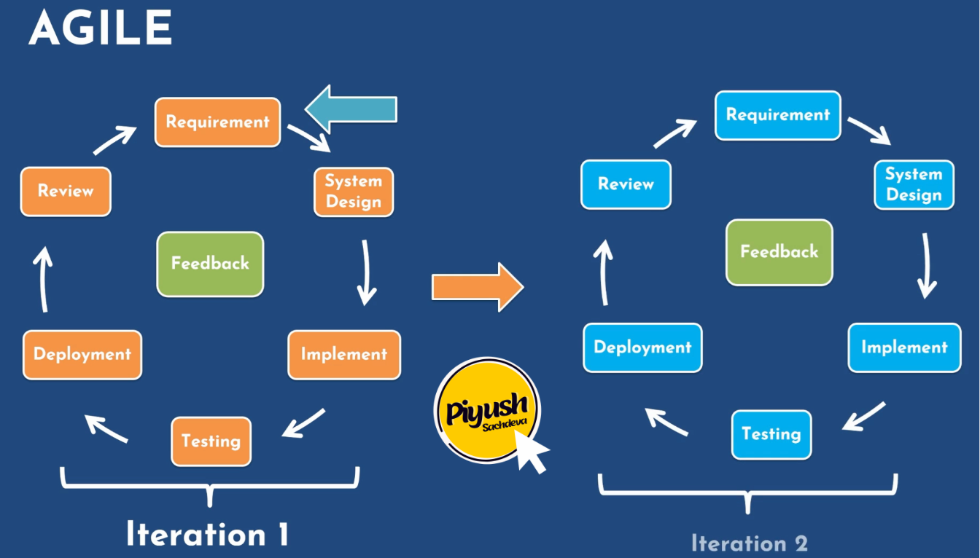

What is DevOps, and why does it matter?

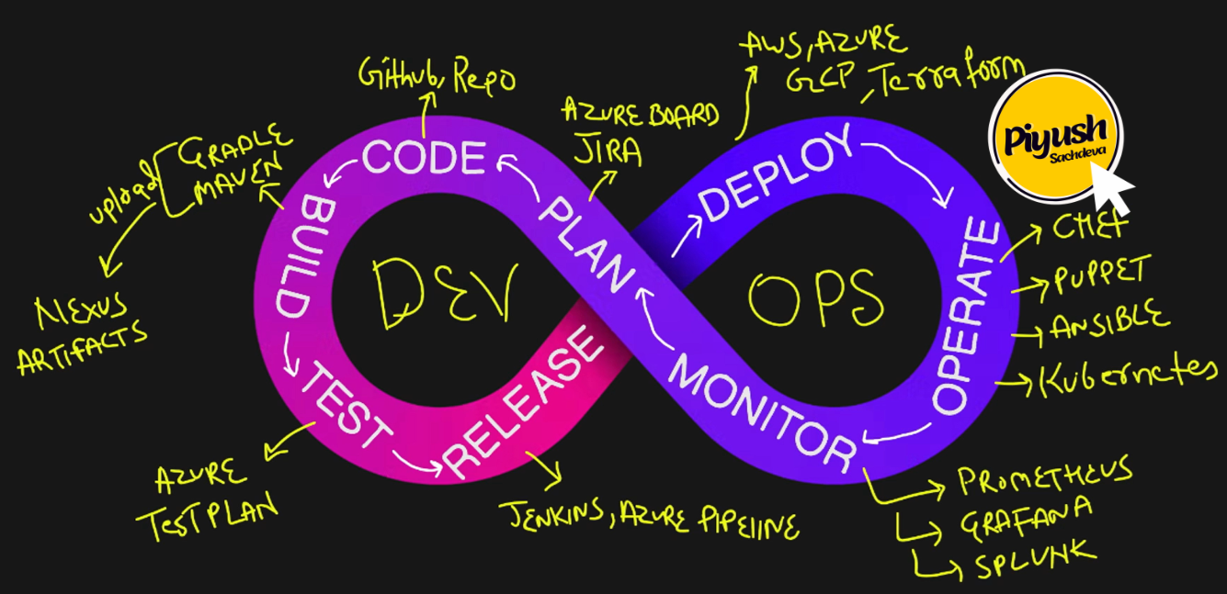

1. Plan
2. Code
3. Build
4. Test
5. Release
6. Deploy

What is Azure DevOps 🤷‍♂️
Azure DevOps is a suite of services that allows you to implement end-to-end DevOps in your organization. It includes services such as Azure Repos, Boards, Wikis, Build and Release pipelines, Test plans, and Artifacts.
Type of Hosting Options 🚀
You can work in the cloud using Azure DevOps Services or on-premises using Azure DevOps Server. Organizations that want complete control over their data would mostly prefer to use Azure DevOps Server. We will use the cloud offering Azure DevOps Services throughout our course.
Pricing 💲💲💲
In the basic plan, you will get the first 5 users free of cost with all the services within certain limits except the Azure test plan, for which you need a Basic+Test plan subscription/
Below are the details of both plans:

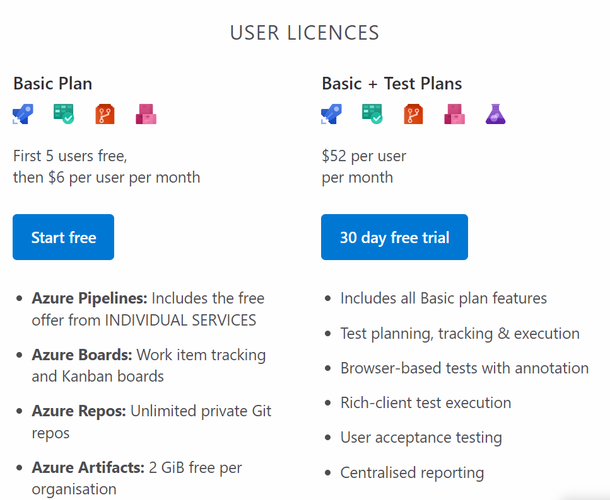

Below are the service limits applicable to these plans

